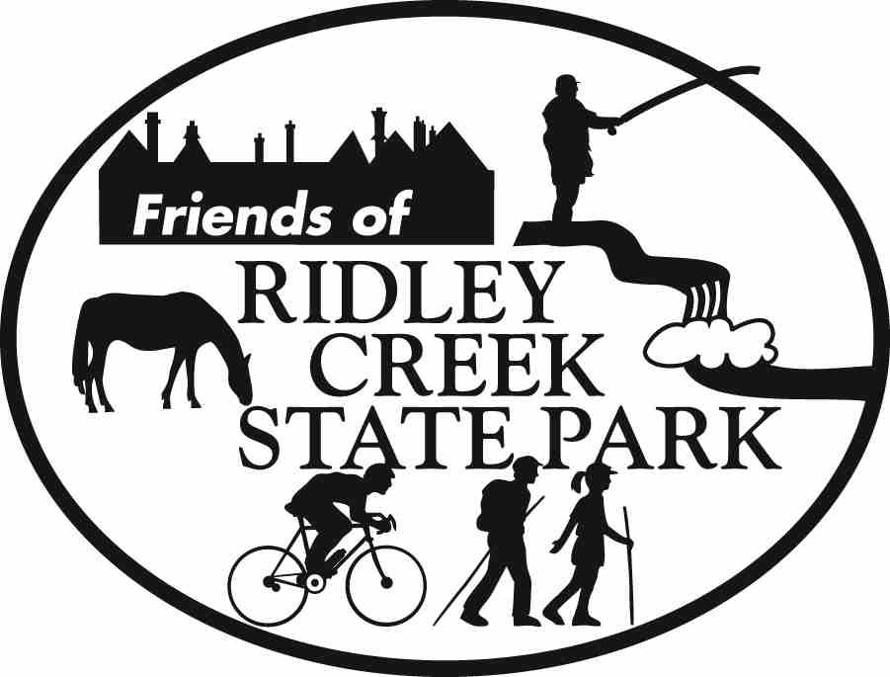

Dear Friend of Ridley Creek State Park,
PHOTO CONTEST REMINDER!

The deadline for photo submissions is October 30, 2005. Entries must be dropped off in person at the Ridley Creek state park office front desk between Oct. 8 and Oct. 30 during park hours.

There is still time! Visit our homepage at www.friendsofrcsp.org for rules, requirements, ideas and entry forms. Public Viewing of photos and Awards Ceremony will be held on Sunday, November 13th from 1pm-3pm in the mansion ballroom. If you are not a member of the Friends of Ridley Creek State Park, now would be a great time to meet other members and join!

Questions: Call 610 - 876-4470

TRAILS

The trails group meets the first Saturday of each month to clear trails of debris, downed trees or special projects. Meet at the Park Headquarters November 5th at 9am. Trail work lasts until 12pm with refreshments served afterwards. If you are interested in being a part of this group, please contact Howard Sherman at HowardSherman@att.net or (610) 626-0751

As part of our ongoing efforts to improve the park, the Friends of Ridley Creek State Park were awarded a $600 grant from the Appalachian Mountain Club. This awared is earmarked for Universal All-Access Trail, which is the trail that loops behind the mansion and is being improved so that persons of all abilities may use it.

Tim Higgins, Maureen Wade and John Kennedy received formal citations from the Pennsylvania House of Representatives for their bravery and quick thinking when power lines were downed on the multi-use trail on April 2nd. Through their excellent judgment and quick thinking, they were able to secure the safety of the trailworkers and park users and avert the possibility of serious injury to themselves and others. The awards were formally presented on October 7th .

Dr. Howard Sherman, Chairman of the Trails Committee, spoke at at the Willistown Friends Meeting Environmental Stewardship Day, Oct. 16th, "Environmental Stewardship in Our Parks and Forests." The purpose of the talk was to increase awareness of the Friends of Ridley Creik State Park and what individuals can do to help the environment. If you know of an event where the Friends can take part, please contact Howard at HowardSherman@att.net or (610) 626-0751

MEMBERSHIP

We are in the process of collecting membership dues for the 2005-2006 year. Please remember that the Friends of Ridley Creek State Park is a qualified 501(c)(3) organization which means that your donations are tax deductible. You can join or renew for as little as $10.00. Check our website for details. Make checks payable to PPFF-FORCSP. Special promotions this month for signing up a friend! Do you know of a business who would give a business discount to Friends members? If so, please contact Tim Higgins at President@FriendsofRCSP.org.

HOLIDAY HISTORIC HOUSE TOUR

For the first time ever, The Friends of Ridley Creek State Park will host its very own Holiday Historic House Tour in and around Ridley Creek State Park. Ridley Creek State Park is a historic place of its own, but is also surrounded by beautiful and historic homes…some of which will be on the tour.

“People who live in the area and use the Park are excited about seeing the homes and getting a personal sense of history of the area. Some of the houses date back to the 1700’s and all but one of the houses are in close proximity to each other.” said Carol Rubin, organizer of the Tour. “In addition, as with all Friends fundraisers, the proceeds will go directly towards filling budgetary gaps (from the state) for repair and maintenance of the gardens, grounds, fountains and Mansion at Ridley Creek State Park” added Tim Higgins, President of the Friends.

When: Saturday, December 10th from 10 a.m. to 3 p.m. The tour will start at and include Hunting Hill Mansion (Park Office). Maps and details on each house will be handed out at that time. Coffee, Tea and refreshments will be served in the Ballroom.

Cost: $20 if you register and payment is received by December 8^{th.} $25 at the door. $15 for Friends Members. Make checks payable to PPFF-FORCSP and mail to: Friends of Ridley Creek State Park – Historic Holiday House Tour c/o Ridley Creek State Park 1023 Sycamore Mills Rd. Media, PA 19063-4398

The event will be held snow, rain or shine. For questions or information about the tour due to severe inclement weather, please call 610-565-3877.

