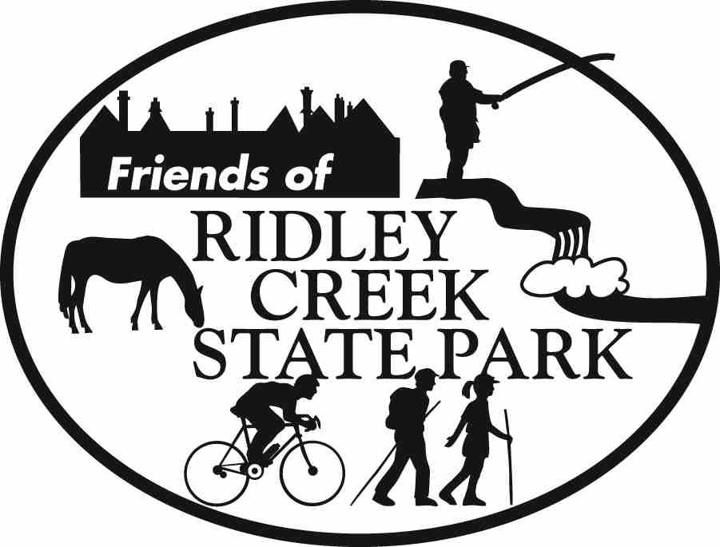

Dear Friend of Ridley Creek State Park,
The Friends of Ridley Creek State Park has undergone wonderful changes over the past few months. We’ve got new members and volunteers who are very committed to the cause: Preserving, Protecting and Enhancing Ridley Creek State Park. With the organization continuously growing and changing, we’d like to take a moment to acknowledge the officers, some old, some new and a few stand-out volunteers.

WHO’S WHO?
President: Tim Higgins
Vice President: Jack Miller
Recording Secretary: Gary Sawyer
Treasurer: John Kennedy
Events: Carol Rubin
Photo Contest: Patti Kelly
Public Relations: Pam Pennewell
Trails: Dr. Howard Sherman
Webmaster: Ted Uhlman

AWARDS
Tim Higgins, Maureen Wade and John Kennedy received formal citations from the Pennsylvania House of Representatives for their bravery and quick thinking when power lines were downed on the multi-use trail on April 2nd. Through their excellent judgment and quick thinking, they were able to secure the safety of the trailworkers and park users and avert the possibility of serious injury to themselves and others.

You don’t need go to these lengths to be a hero-- everyone who helps the park in any way is a hero! Trailworkers meet the first Saturday of each month from 9am-12pm regardless of weather. Contact Howard Sherman at (610) 626-0751 or Trails@FriendsOfRCSP.org to register.

SUPER SUNDAY - SEPTEMBER
The Friends of Ridley Creek State Park will have a booth at Super Sunday in Media September 11th. This is the season for membership renewal and focus on attracting new members. If you are there, please stop by. If you are interested in volunteering, please let us know by replying to this email.

HISTORY LESSON AT HUNTING HILL-October 7th

To many, Ridley Creek State Park is a beautiful place to visit and a great place to picnic, bike, hike and/or run with its 2400 acres of open space. Ridley Creek State Park is not just another pretty place… did you know that Ridley Creek State Park is also rich with history?

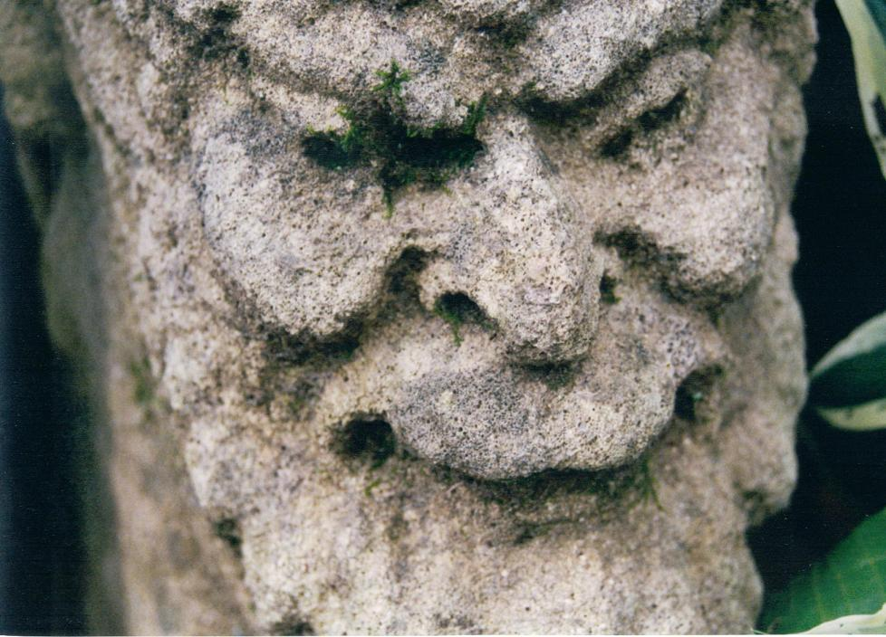

On Friday, October 7th at 7 p.m. in the ballroom of the Hunting Hill Mansion (park office) you can learn more about this wonderful Park. Mitch Beaver will give a slide presentation of the Historic Mill Area in Ridley Creek State Park along with his extensive knowledge of the area’s history. Kay Ferrari will give a brief talk on the Sam Riddle - Walter Jeffords connection just prior to Mitch's presentation.

So forget the movies on this Friday October 7th and do something different with the family—pack a picnic dinner to enjoy outside and head for the Hill, Hunting Hill, that is and stay for the presentation.

Refreshments will be served. Cost: $5 per person; Free to Members of Friends of Ridley Creek State Park and children under 16.

PHOTO CONTEST-November 13th

If you haven’t started your picture taking yet for the Annual Photo Contest it’s time to get into action! Peak photography season is right around the corner at Ridley Creek State Park. Check out the multi-use trail, the hidden pathways that lead to the mansion, the formal gardens and historic homes. See our homepage at www.friendsofrcsp.org for rules, requirements, ideas and entry forms. Entries will be accepted at the Ridley Creek state park office front desk between Oct. 8 and Oct. 30 during park hours. Awards ceremony will be held on Sunday, November 13th in the mansion ballroom.

Willistown Friends Environmental Stewardship Conference-Oct. 16th

A day-long series of events, including participation by over 20 environmental groups. Theme: “What can an individual do to protect and restore our environment?
Friends of Ridley Creek State Park will give a special presentation on opportunities in the Park. Time: 11am-6pm at the Willistown Friends Meeting, Providence Road, Willistown, PA. Free Event.
MEMBERSHIP

We are in the process of collecting membership dues for the 2005-2006 year. Please remember that the Friends of Ridley Creek State Park is a qualified 501(c)(3) organization which means that your donations are tax deductible. You can join or renew for as little as $10.00. Special promotions this month for signing up a friend! Do you know of a business who would give a business discount to Friends members? If so, please contact Tim Higgins at President@FriendsofRCSP.org.

LOOKING AHEAD
Stay tuned for more information about our planned Holiday Event on December 10th, which will include a Historic House Tour of homes in Ridley Creek State Park. Details to come!

If you are interested in hearing about upcoming activities and events, you can sign up by going to our website at www.friendsofrcsp.org and following the directions on the home page.

